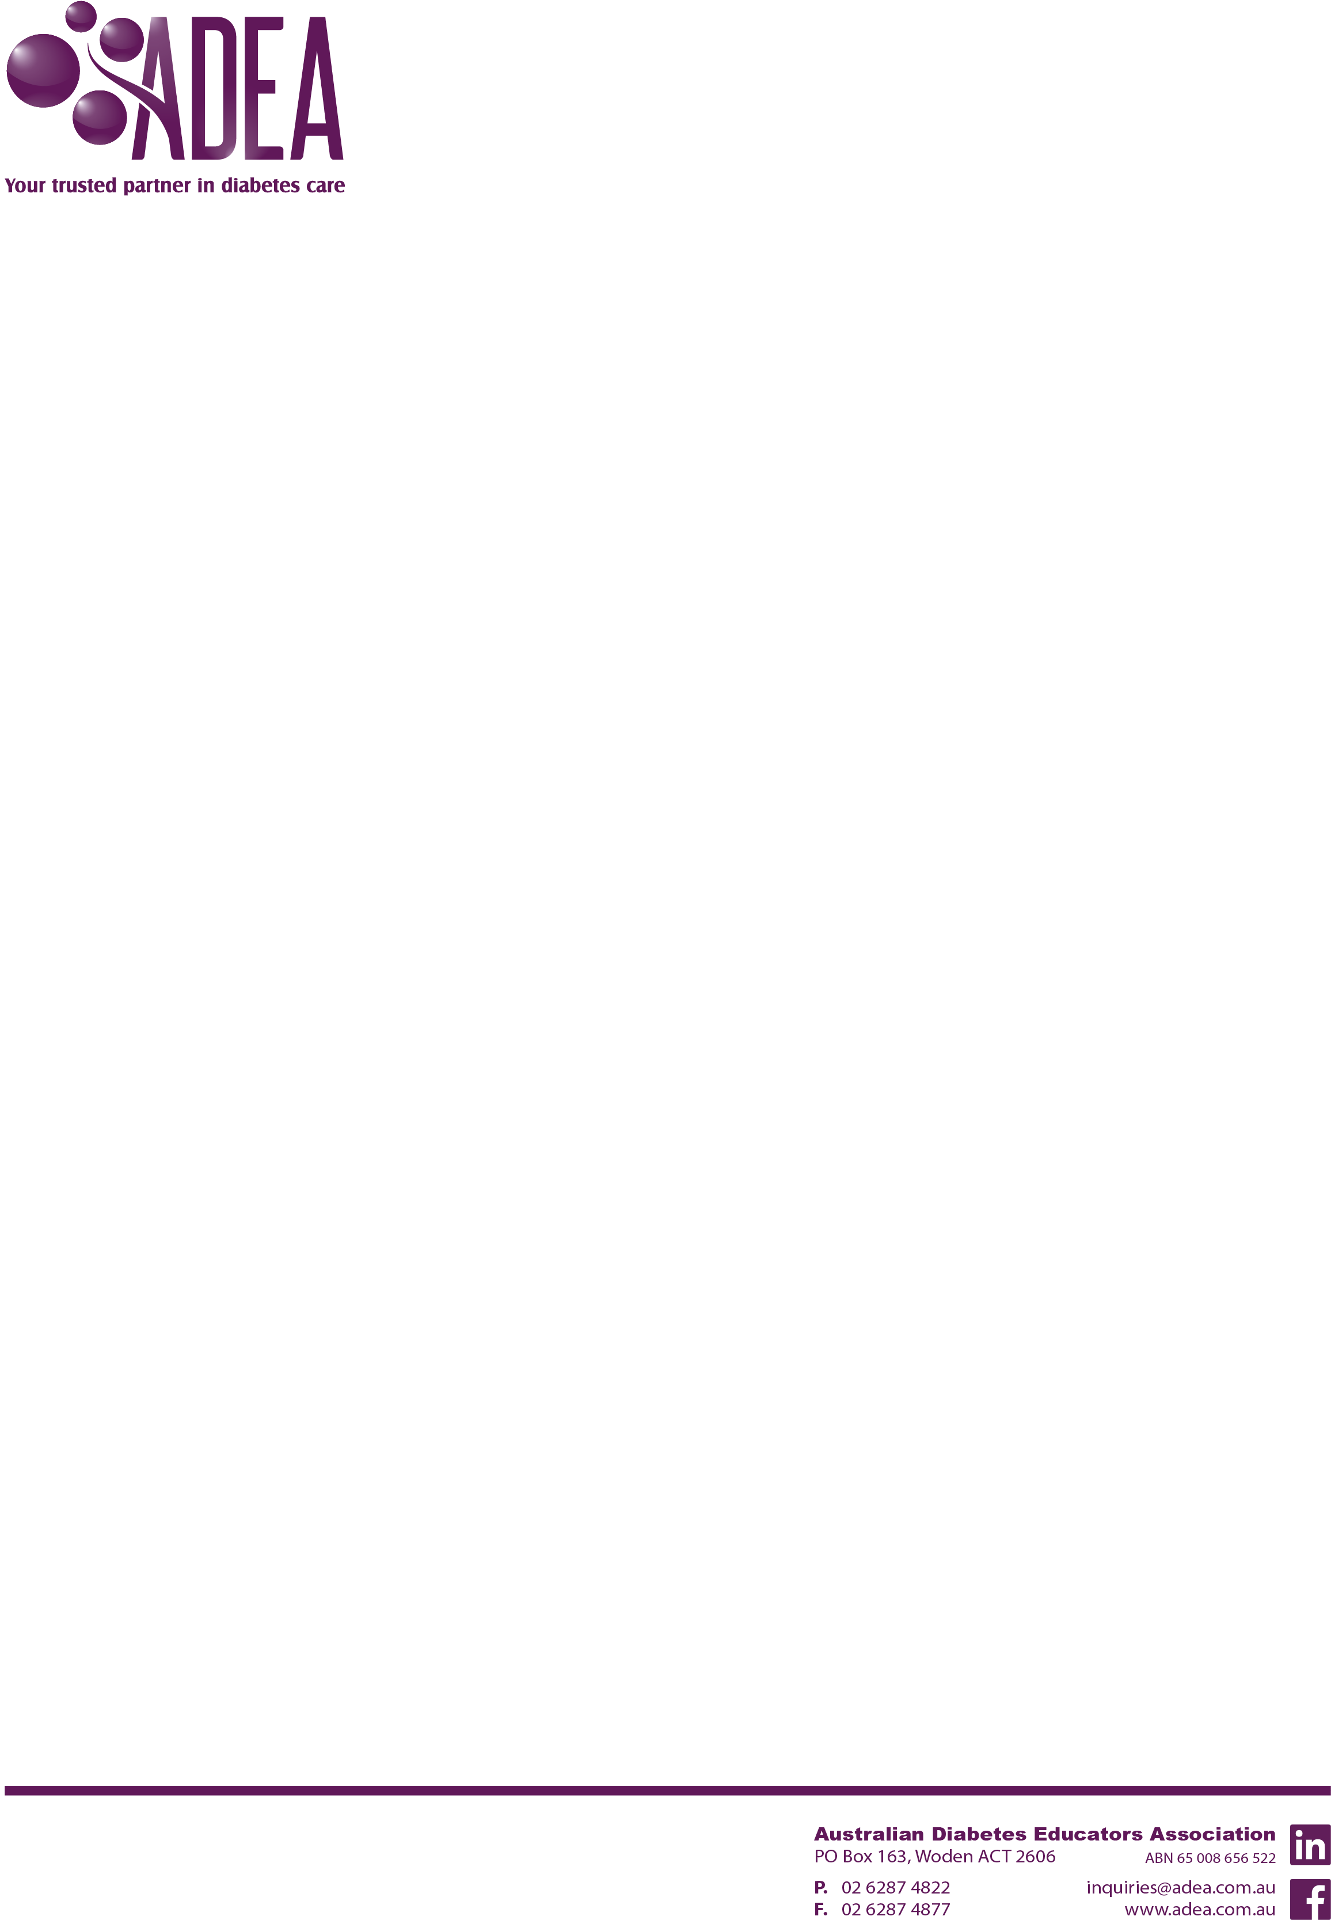
Australian Diabetes Educator publication

Copyright permission request
For ADE lead/corresponding author
If you include any third party materials in your manuscript, please contact the authors/copyright holders to seek their permission for you to use their materials in your manuscript.
Third party material is non-textual in nature, i.e. figure, table, equation, graph, image, media file, etc., that has been published before.
There are two components to this form:
- Copyright permission request for you to complete
- Copyright approval for the copyright holder to complete
You will need to:
- Complete the Copyright permission request on page 2
- Remove this instruction page
- Forward page 2 and page 3 to the copyright holder
- Once the copyright holder completes page 3, forward both page 2 and page 3 to the ADE Publication team on ade@adea.com.au.

<<Details of lead/corresponding author>>
Title: Full name:
Work title:
Workplace:
Postal address:
Suburb: Postcode: State:
Email address:
Phone number:

<<date>>
<<Details of the copyright holder>>
Title: Full name:
Work title:
Workplace:
Postal address:
Suburb: Postcode: State:
Email address:
Phone number:

Dear <<title>> <<full name of copyright holder>>

Copyright permission request

I would like to include the following material:
Publication title:
Author:
Publication date:
Material (figure, table, quote, etc.):
Page number:

In an article I submitted to the Australian Diabetes Educators Association for the ADE publication:
Manuscript Title:
Date of lodgement of article:
Lead/Corresponding author name:

If you can complete your details on the Copyright approval on the next page and return to me at your earliest convenience, that would be greatly appreciated.

My contact details for further information are:
Email address:
Phone number:

I look forward to hearing from you on this and thank you so much for your support.

Kind regards,
<<title>> <<full name of lead/corresponding author>>

Copyright approval
If you are the copyright holder of the above materials, please complete this Copyright Approval.
I grant the permission requested above.
Signed: Date:
Suitable credit will be given in the use of the materials. If you have a preferred statement, please indicate it below.

***
If you are not the copyright holder of the above materials, please indicate to whom I should apply.
I am not the copyright holder. Please forward this form to the contact below:
To:
Work title: Workplace:
Postal address:
Suburb:
Postcode: State:
Email address: Phone number:

